**E115 – Programming and Data Analysis**

**Practice questions for Lesson 02**

**For… Next**

1. What is the value stored in the variable “Cash” after the following “For… Next” loop has finished running?

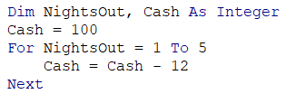

1. 0
2. 40
3. 60
4. 100
5. Copy the following row of letters into a new Excel sheet. Write a “FOR… NEXT” loop to count the number of “B”s that appear in the row.

|  |  |  |  |  |  |  |  |  |  |  |  |  |  |  |  |  |  |  |  |  |  |  |  |  |  |  |  |  |  |
| --- | --- | --- | --- | --- | --- | --- | --- | --- | --- | --- | --- | --- | --- | --- | --- | --- | --- | --- | --- | --- | --- | --- | --- | --- | --- | --- | --- | --- | --- |
| R | R | R | R | R | R | R | B | R | R | R | B | R | R | B | R | R | R | B | R | R | R | R | R | B | R | R | R | R | R |

1. Write a nested “FOR… NEXT” loop to write the sentence “I will get an A for E115” into all the cells from A1 to I10, as shown below.

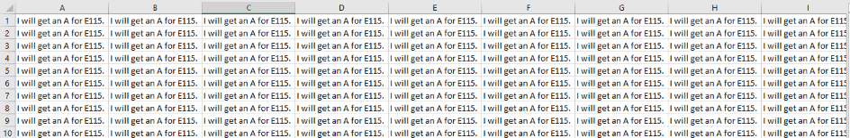

1. Copy the following table into a new Excel sheet. Write a nested “FOR… NEXT” loop to go through the table and colour all the cells with the letter “B” yellow.

|  |  |  |  |  |  |  |  |  |  |  |  |  |  |  |  |  |  |  |  |  |  |  |  |  |  |  |  |  |  |
| --- | --- | --- | --- | --- | --- | --- | --- | --- | --- | --- | --- | --- | --- | --- | --- | --- | --- | --- | --- | --- | --- | --- | --- | --- | --- | --- | --- | --- | --- |
| R | R | R | R | R | R | R | R | R | R | R | R | R | R | R | R | R | R | R | R | R | R | R | R | R | R | R | R | R | R |
| R | R | B | R | R | R | R | R | R | R | R | R | R | R | R | R | R | R | R | B | R | R | R | R | R | R | R | R | R | R |
| R | R | R | R | R | R | R | R | R | R | R | R | R | R | R | R | R | R | R | R | R | R | R | R | R | R | R | R | R | R |
| R | R | R | R | R | B | R | R | R | R | R | R | R | R | R | R | R | R | R | R | R | R | R | R | R | R | R | R | R | R |
| R | R | R | R | R | R | R | R | R | R | R | R | R | R | R | R | B | R | R | R | R | R | R | R | R | R | R | R | R | R |
| R | R | R | R | R | R | R | R | R | R | R | R | R | R | R | R | R | R | R | R | R | R | R | R | R | R | R | R | R | R |
| R | R | R | R | R | R | R | R | B | R | R | R | R | R | R | R | R | R | R | R | R | R | R | R | R | R | R | R | R | R |
| R | R | R | R | R | R | R | R | R | R | R | R | R | R | R | R | R | R | R | R | R | R | R | R | R | R | R | R | R | R |
| R | R | R | R | R | R | R | R | R | R | R | R | R | R | R | R | R | R | R | R | R | R | R | R | R | R | R | R | R | R |
| R | R | R | R | R | R | R | R | R | R | R | R | R | R | R | R | R | R | R | R | R | R | R | R | R | R | R | R | R | R |
| R | R | R | R | R | R | R | R | R | R | R | R | R | R | R | R | R | R | R | R | R | R | R | B | R | R | R | R | R | R |
| R | R | R | R | R | R | R | R | R | R | R | R | R | R | R | R | R | R | R | R | R | R | R | R | R | R | R | R | R | R |
| R | R | R | R | R | R | R | R | R | R | R | R | R | R | R | R | R | R | R | R | R | R | R | R | R | R | R | R | R | R |
| R | R | R | R | R | R | R | R | R | R | R | R | R | R | R | R | R | R | R | R | R | R | R | R | R | R | R | R | R | R |
| R | R | B | R | R | R | R | R | R | B | R | R | R | R | R | R | R | R | R | R | R | R | R | R | R | R | R | R | R | R |
| R | R | R | R | R | R | R | R | R | R | R | R | R | R | R | R | R | R | R | R | R | R | R | R | R | R | R | R | R | R |
| R | R | R | R | R | R | R | R | R | R | R | R | R | R | R | R | B | R | R | R | R | R | R | B | R | R | R | R | R | R |
| R | R | R | R | R | R | R | R | R | R | R | R | R | R | R | R | R | R | R | R | R | R | R | R | R | R | R | R | R | R |
| R | R | R | R | R | R | R | R | R | R | R | R | R | R | R | R | R | R | R | R | R | R | R | R | R | R | R | R | R | R |
| R | R | R | R | R | R | R | R | R | R | R | R | R | R | R | R | R | R | R | R | R | R | R | R | R | R | R | R | R | R |
| R | R | B | R | R | R | R | R | R | R | R | R | R | R | R | R | R | R | R | B | R | R | R | R | R | R | R | R | R | R |
| R | R | R | R | R | R | R | R | R | R | R | R | R | R | R | R | R | R | R | R | R | R | R | R | R | R | R | R | R | R |

1. Write a “FOR… NEXT” loop to write the word “Even” into Row 1 cells that are in even columns, as shown below. The last column to write in is Column V.



1. Write a “FOR… NEXT” loop to write the word “Odd” into Column A cells that are in odd rows, as shown below. The last row to write in is Row 23.



1. Write a nested “FOR… NEXT” loop to create the following table in Excel:

